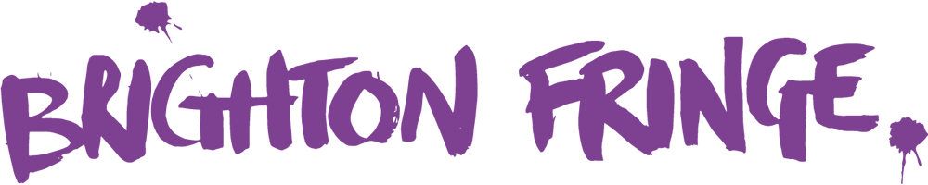

Venue Managers’ Meeting Minutes 18 December 2023
Hosted at The Brighton Toy Museum and on Zoom
Attending from BF:
Rhiannon Lingwood - Marketing Manager / Artists & Venue Manager
Sarah French – Artists Services Assistant
Maddie Lock – Artist Marketing Co-ordinator
Duncan Lustig-Prean – Chair

Attending From VMS:
Rhiannon Rolf – Marina Studios
Philip Davis – St Mary’s Church
Ross and Michelle Ericson – The Rotunda
Jan Etches – Brighton Toy Museum
Ali – Wachart Gallery

- Marketing Managers Update

Spark Arts Marketing will be our marketing team for 2024. They have previously worked on Milton Keynes International Festival and Spill Ipswich. They will begin in January 2024.
- Artist Observers and Venue Observer to the Board
Our new artist observers have been confirmed by the board.
- James (Biscuit Barrel)
- Kate (Carnival Collective/Boxes)
- Alex (Fanny Dent/The Burlesque Imposter)
You can read more about them here: https://www.brightonfringe.org/fringe-info/artist-observer-to-the-board-2/

The election for Venue Observer will take place in the New Year – we would love for you to run!

- 3 New Venues for 2024
There are 105 venues registered so far, 61 with finalised events.
New venues include, among others:
Laughing Horse @ The Windmill
Bleach (above Hare and Hounds)
Headfirst Acrobats (bringing their own outdoor pop-up venue which will be on south ground of St Peters)
Marina Studios
The Dance Space

- Winter Showcase Feedback

£322.50 raised
5 performances from: Timothy Quinlan, Paggy, Kitty Cassis, Dru Cripps and The Fabulous Red Diesel
Thanks to all our supporters who donated raffle prizes.

Based on the success of the December showcase, a second showcase is being planned for February to take place at Daltons Beach Bar and Cabaret.

We hope to produce more of these shows and other events throughout the year, If your venue is interested is hosting any future Brighton Fringe events, let us know!

- Venue Manager Bursary Winners

Winners of the Venue Managers Bursaries were drawn at the last meeting::

- The Brunswick, Hove
- Laughing Horse – The Quadrant
- Artista
- Arcobaleno
- City Coast Centre
- The Actors
- The Caroline of Brunswick
- Laughing Horse – The Temple Bar
- Brighton Unitarian Church
- The Bees Mouth
The 10 venues who are supported by this bursary will each receive:
3x Lamppost board advertising sides
1x Solus email to marketing database (approx. 18k subscribers)
1x Social media post on Instagram and Facebook (approx. 35k followers)
1x 1hr mentoring with the Brighton Fringe team for marketing or programming your venue

Bursary winners will be contacted again in the new year to arrange mentoring sessions etc.

- Duncan Lustig Prean (Chair of the Board Updates)
https://www.brightonfringe.org/wp-content/uploads/2023/12/Board-Meeting-VM-Brief.pdf

- Venue Manager Updates

Rotunda: Bookings are 3 tiimes higher than this time last year so it’s going to be a busy season! 44 confirmed acts vs 64 by May last year. So far no real issues and a good variety of shows from across all genres.

Brighton Toy Museum: Don’t look to book for the whole month but rather focus on shows that compliment the setting, particularly family shows/ horror stories/ history. The focus is on publicity for the Museum and finding new audiences rather than lots of shows. Very happy with the quality and amount of acts booked so far.

Wachart Gallery: First meeting and first Fringe as a new venue. Small capacity but keen to be involved and host a variety of shows. Also an exhibition space.
Marina Studios: Not many enquiries so far, but the refurb has started and is well underway. Need to do more marketing once time to focus on it and identify the advantages of being based further out of town.

St. Mary’s: Not a dedicated events venue, so not looking to book a full programme, First time booking out the Church Hall as well as the Church building itself and the hall is receiving more bookings so far which is very exciting. Also hosting own event in Fringe for the first time. Will have something on every week in May and could even potentially now host two shows simultaneously in different spaces.

- Flyering Update

Clarifying the current flyering conditions imposed by Brighton and Hove Council. For details please see our website. Please let us know if you experience any issues with flyering.

- AOB

The Artists Services Team will based a the Ledward Centre again for Fringe 2024, and wil continue to host coffee mornings and networking events as it has done in the past.
The Box Office will be based at the Head First Acrobats site at St Peters.

The next Venue Managers’ Meeting will take place in January, Date and Venue TBC.

.

