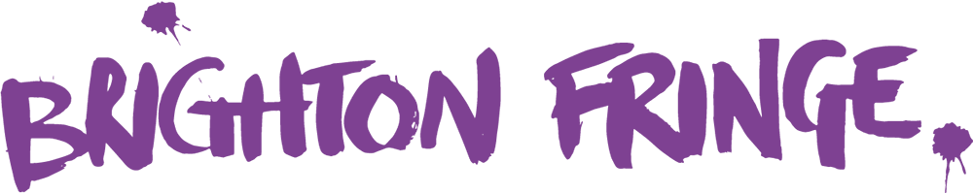

EQUAL OPPORTUNITIES POLICY

Brighton Fringe does not discriminate against any paid or unpaid staff on the basis of their gender, sexual orientation, marital or civil partner status, gender reassignment, race, colour, nationality, ethnic or national origin, religion or belief, disability or age. The principle of non-discrimination and equality of opportunity applies equally to the treatment of former staff, visitors, clients, customers and suppliers by members of our current workforce.

The measures we take to implement the principle of non-discrimination have been devised on the basis of advice from the relevant governmental and professional bodies as well as in consultation with appropriate union and/or workers' representatives. We are committed to a programme of action to make this policy effective and to bring it to the attention of all staff.

This policy deals with the specific categories of staff and areas of work which we have identified as potentially giving rise to equal opportunities issues and provides more specific guidance on the parameters of our policy and approach to equal opportunities.

All staff have a duty to act in accordance with this policy, and therefore to treat colleagues with dignity at all times, and not to discriminate against or harass other members of staff, whether junior or senior to them. In some situations, we may be at risk of being held responsible for the acts of individual members of staff and will not therefore tolerate any discriminatory practices or behaviour.

Scope and purpose of the policy

This policy applies to the advertising of jobs and recruitment and selection, to training and development, opportunities for promotion, to conditions of service, benefits and facilities and pay, to health and safety and to conduct at work, to grievance and disciplinary procedures and to termination of employment, including redundancy.

We will take appropriate steps to accommodate the requirements of workers' religions, cultures, and domestic responsibilities.

Forms of discrimination

Discrimination may be direct or indirect and it may occur intentionally or unintentionally.

Direct discrimination occurs where someone is put at a disadvantage for a reason related to one or more of the grounds set out in paragraph 1.1. For example, rejecting an applicant on the grounds of their race because it is considered they would not "fit in" could be direct discrimination.

Indirect discrimination occurs where an individual is subject to an unjustified provision, criterion or practice which puts them at a particular disadvantage because of, for instance, their sex or race. For example, a height requirement would be likely to eliminate proportionately more women than men. If this criteria cannot be objectively justified for a reason unconnected with sex, it would be indirectly discriminatory on the grounds of sex.

Discrimination also includes victimisation (less favourable treatment because of action taken to assert legal rights against discrimination or to assist a colleague in that regard) and harassment (which is dealt with under our Anti-harassment Policy).

Disability discrimination

If you are disabled, or become disabled, you are encouraged to tell us about your condition. This is to enable us to support you as much as possible. You may also wish to advise your line manager any reasonable adjustments to your working conditions or the duties of your job which you consider to be necessary, or which would assist you in the performance of your duties. Your line manager may wish to consult with you and with your medical adviser(s) about possible reasonable adjustments. Careful consideration will be given to any such proposals and they will be accommodated where possible and proportionate to the needs of your job. Nevertheless, there may be circumstances where it will not be reasonable for us to accommodate suggested adjustments and we will ensure that we provide you with information as to the basis of our decision not to make any adjustments.

We will monitor the physical features of our premises to consider whether they place disabled workers, job applicants or service users at a substantial disadvantage compared to other staff. Where possible and proportionate, we will take steps to improve access for disabled staff and service users.

Breaches of the policy

If you believe that you may have been discriminated against you are encouraged to raise the matter through our Grievance Procedure. If you believe that you may have been subject to harassment you are encouraged to raise the matter through our Anti-harassment Policy. If you are uncertain which applies to you or need advice on how to proceed you should speak to the Executive Manager.

Allegations regarding potential breaches of this policy will be treated in confidence and investigated in accordance with the relevant procedure. Staff who make such allegations in good faith will not be victimised or treated less favourably as a result. False allegations which are found to have been made in bad faith will, however, be dealt with under our Disciplinary Procedure.

Any member of staff who is found to have committed acts of discrimination or harassment will be subject to disciplinary action. Such behaviour may constitute gross misconduct and, as such, may result in summary dismissal. We always take a strict approach to serious breaches of this policy.

Last Reviewed: 14th December 2016
Approved by: Julian Caddy, CEO
Reviewed date: 14 August 2020
Next Review: 1 August 2021

