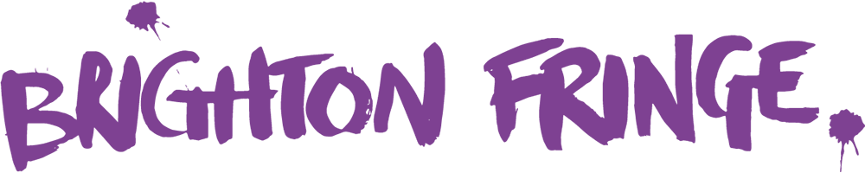

Complaints policy & procedure

Brighton Fringe is BRIGHTON FRINGE LTD, a limited company incorporated in England and Wales with company number 05578256 and a charity registered in England and Wales (charity number registration number 1116367) having its registered office at Yacht Werks, 28-29 Richmond Place, Brighton BN2 9NA
Brighton Fringe is committed to providing a quality service for its customers, stakeholders and partners, and working in an open and accountable way.
Brighton Fringe recognises the need to continue to improve its services by listening and responding to the views of its stakeholders, customers and partners, and in particular by responding positively to complaints, and by putting mistakes right.
Therefore, we aim to ensure that:
- The complaint procedure is clear and easy to use for anyone wishing to make a complaint
- We treat a complaint as a clear expression of dissatisfaction with our service which calls for an immediate response
- We make sure all complaints are investigated fairly, confidentially and in a timely way
- We make sure that complaints are, wherever possible, resolved and that relationships are repaired
- We learn from complaints, use them to improve our service, and annually review our complaints policy and procedures
Definition of a Complaint
A complaint is any expression of dissatisfaction, whether justified or not, about any aspect of Brighton Fringe. A complaint can be received verbally, by phone, by email or in writing.

Informal Complaints Procedure
We recognise that many concerns will be raised informally, and dealt with quickly. Our aims are to:
- Resolve informal concerns quickly
- Keep matters low-key
- Enable mediation between the complainant and the individual to whom the complaint has been referred
An informal approach is appropriate when it can be achieved. But if concerns cannot be satisfactorily resolved informally, then the formal complaints procedure should be followed.

Formal Complaints Procedure
Stage 1
In the first instance, if you are unable to resolve the issue informally, you should write to the member of staff who dealt with you, or their manager, so that he or she has a chance to put things right. If your complaint concerns a Trustee of Brighton Fringe, rather than a member of Brighton Fringe staff, you should write formally to the individual concerned. In your letter you should set out the details of your complaint, the consequences for you as a result, and the remedy you are seeking.
You can expect your complaint to be acknowledged within 5 working days of receipt. You should get a response and an explanation within 15 working days. If you are unsure which member of Brighton Fringe staff to write to, your complaint should be sent to the Brighton Fringe Office & HR Manager.
Our contact details can be found on the Contact Us part of the Brighton Fringe website.
Stage 2
If you are not satisfied with the initial response to the complaint then you can write to the Brighton Fringe CEO (Julian Caddy, via the Office & HR Manager: info@brightonfringe.org or by post the address above) and ask for your complaint and the response to be reviewed. You can expect the CEO to acknowledge your request within 5 working days of receipt and a response within 15 workings days.
Brighton Fringe aims to resolve all matters as quickly as possible. However, inevitably some issues will be more complex and therefore may require longer to be fully investigated. Consequently timescales given for handling and responding to complaints are indicative. If a matter requires more detailed investigation, you will receive an interim response describing what is being done to deal with the matter, and when a full reply can be expected and from whom.
Final Stage
If you are not satisfied with the subsequent reply from the Brighton Fringe CEO, then you have the option of writing to the Chair of Brighton Fringe (James Arnell, via the Office & HR Manager: info@brightonfringe.org or via the postal address above) stating the reason why you are dissatisfied with the outcome. You must do this within 10 days of receiving the written response from the Brighton Fringe CEO.
The Chair of Brighton Fringe will respond normally within 10 working days to inform you of the action which will be taken to investigate your complaint, and when you can expect to hear the outcome of the investigation.
This policy will be reviewed annually. It will be circulated to all staff and contractors working in the areas covered.

Approved: 29th April 2019
Approved by: Julian Caddy, CEO
Reviewed date: 8 December 2020
Next review: 8 December 2021

